# Typical Number of Robberies per London Borough - Solution

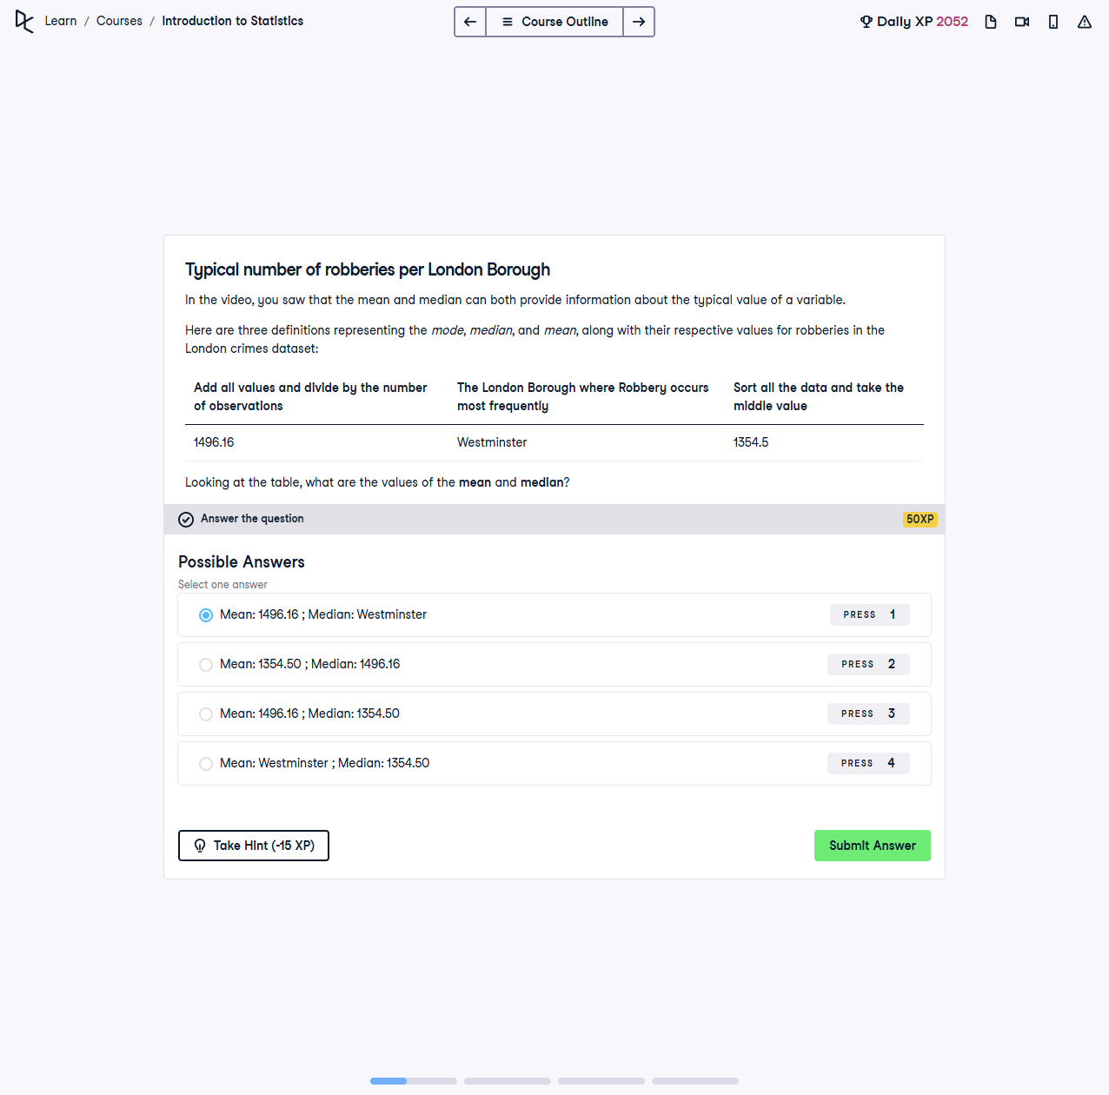

## Question

In the video, you saw that the mean and median can both provide information about the typical value of a variable.  
  
Here are three definitions representing the mode, median, and mean, along with their respective values for robberies in the London crimes dataset:  
- Add all values and divide by the number of observations: **Mean: 1496.16**  
- The London Borough where Robbery occurs most frequently: **Mode: Westminster**  
- Sort all the data and take the middle value: **Median: 1354.5**  
  
Looking at the table, what are the values of the **mean** and **median**?

## Instructions

Choose the correct combination of the mean and median values from the given options.

## Solution

**Correct Answer:**  
- **Mean: 1496.16; Median: 1354.5**

## Solution Explanation

1. The **mean** is calculated by summing all the values and dividing by the number of observations. Here, the mean is **1496.16**.  
2. The **median** is the middle value when the data is sorted. Here, the median is **1354.5**.  
3. The **mode** represents the value or category that occurs most frequently. Here, the mode is **Westminster**, which is not part of this specific question.  
4. The correct combination of **mean** and **median** is: **1496.16 (mean); 1354.5 (median).**